Mohammed Tauseef Asif Shaikh
1. Grade Checker
Take a score as input and print the grade based on the following:
- 90+ : “A”
- 80–89 : “B”
- 70–79 : “C”
- 60–69 : “D”
- Below 60 : “F”
- Use a basic if / else statement to determine the grade.
Source Code:
# Task 1: Grade Checker

# Take the score as an input from the user and convert it to an integer (number)
score_input = input("Enter the student's score (0-100): ")
score = int(score_input)

# Use conditional if/elif/else statements to determine the grade
if score >= 90:
grade = "A"
elif score >= 80:
grade = "B"
elif score >= 70:
grade = "C"
elif score >= 60:
grade = "D"
else:
grade = "F"

# Print the final calculated grade layout
print(f"The calculted grade for a score of {score} is: '{grade}'")

SS:
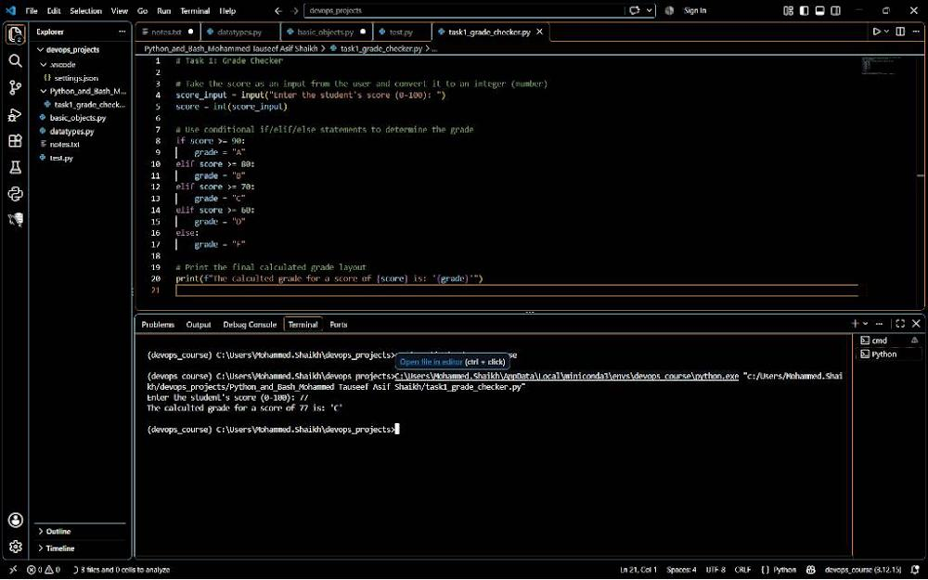

2. Student Grades
Create a dictionary where the keys are student names and the values are their grades. Allow the user to:
- Add a new student and grade.
- Update an existing student's grade.
- Print all student grades.
- Use a dictionary and basic operations with if / else.
Source Code:
# Task 2: Student Grades

# Iinitialize a dictionary with starting data
student_grades = {
"Tauseef": "A",
"Asif": "B"
}
print ("Initial Database:", student_grades)

# 1. Add a new student and grade
new_name = input("\nEnter new student name to add: ")
new_grade = input(f"Enter grade for {new_name}: ")
student_grades[new_name] = new_grade

# 2. Update an existing student's grade
update_name = input("\nEnter existing student name to update: ")
if update_name in student_grades:
update_grade = input(f"Enter new grade for {update_name}: ")
student_grades[update_name] = update_grade
else:
print("Student not found!")

# 3. Print all student grades
print("\n--- Final Student Grades List ---")
for student, grade in student_grades.items():
print(f"Student: {student} | Grade: {grade}" )

SS:
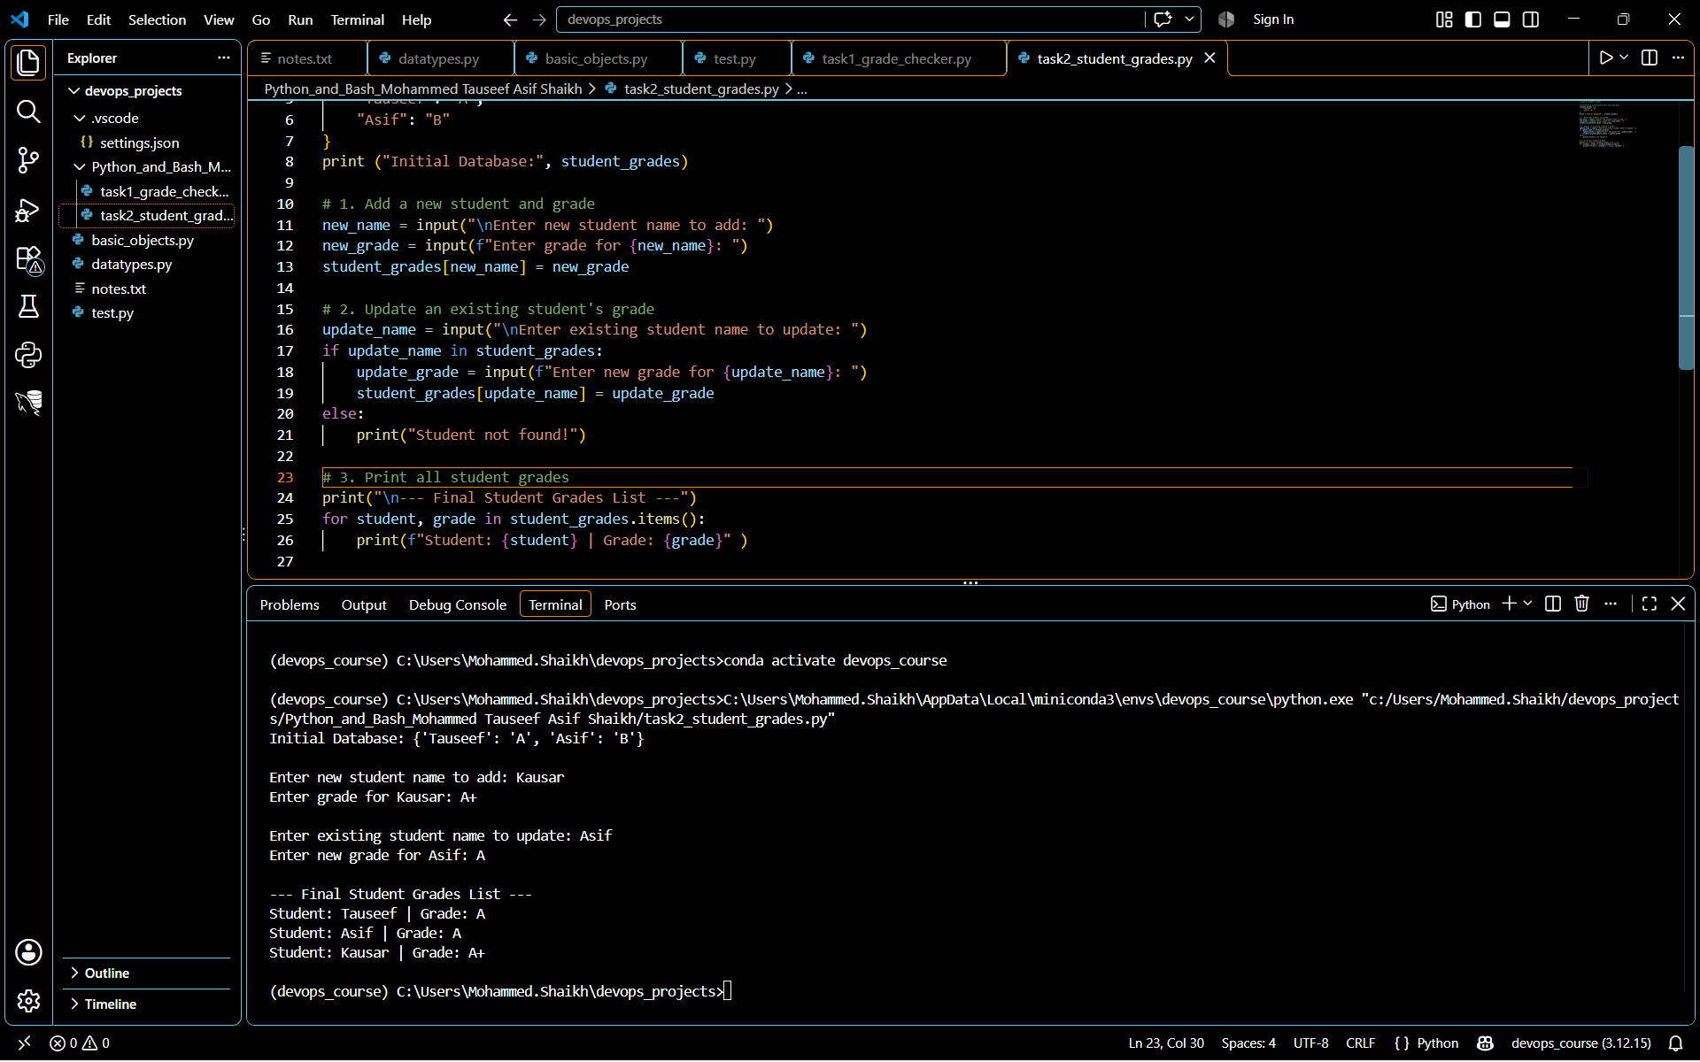
3. Write to a File
- Write a program to create a text file and write some content to it, using file functions like open() and write().
# Task 3: Write to a File

print("--- Task 3: Writing to a File ---")
filename = "devops_notes.txt"

# Open the file in write mode ('w') which creates the file if it doesn't exist
with open(filename, "w") as file:
file.write("Hello DevOps World!\n")
file.write("This text file was created automatically using Python.\n")
file.write("Core file handling operations practiced: open() and write().\n")

print(f"Success! Content successfully written to '{filename}'.")

SS:
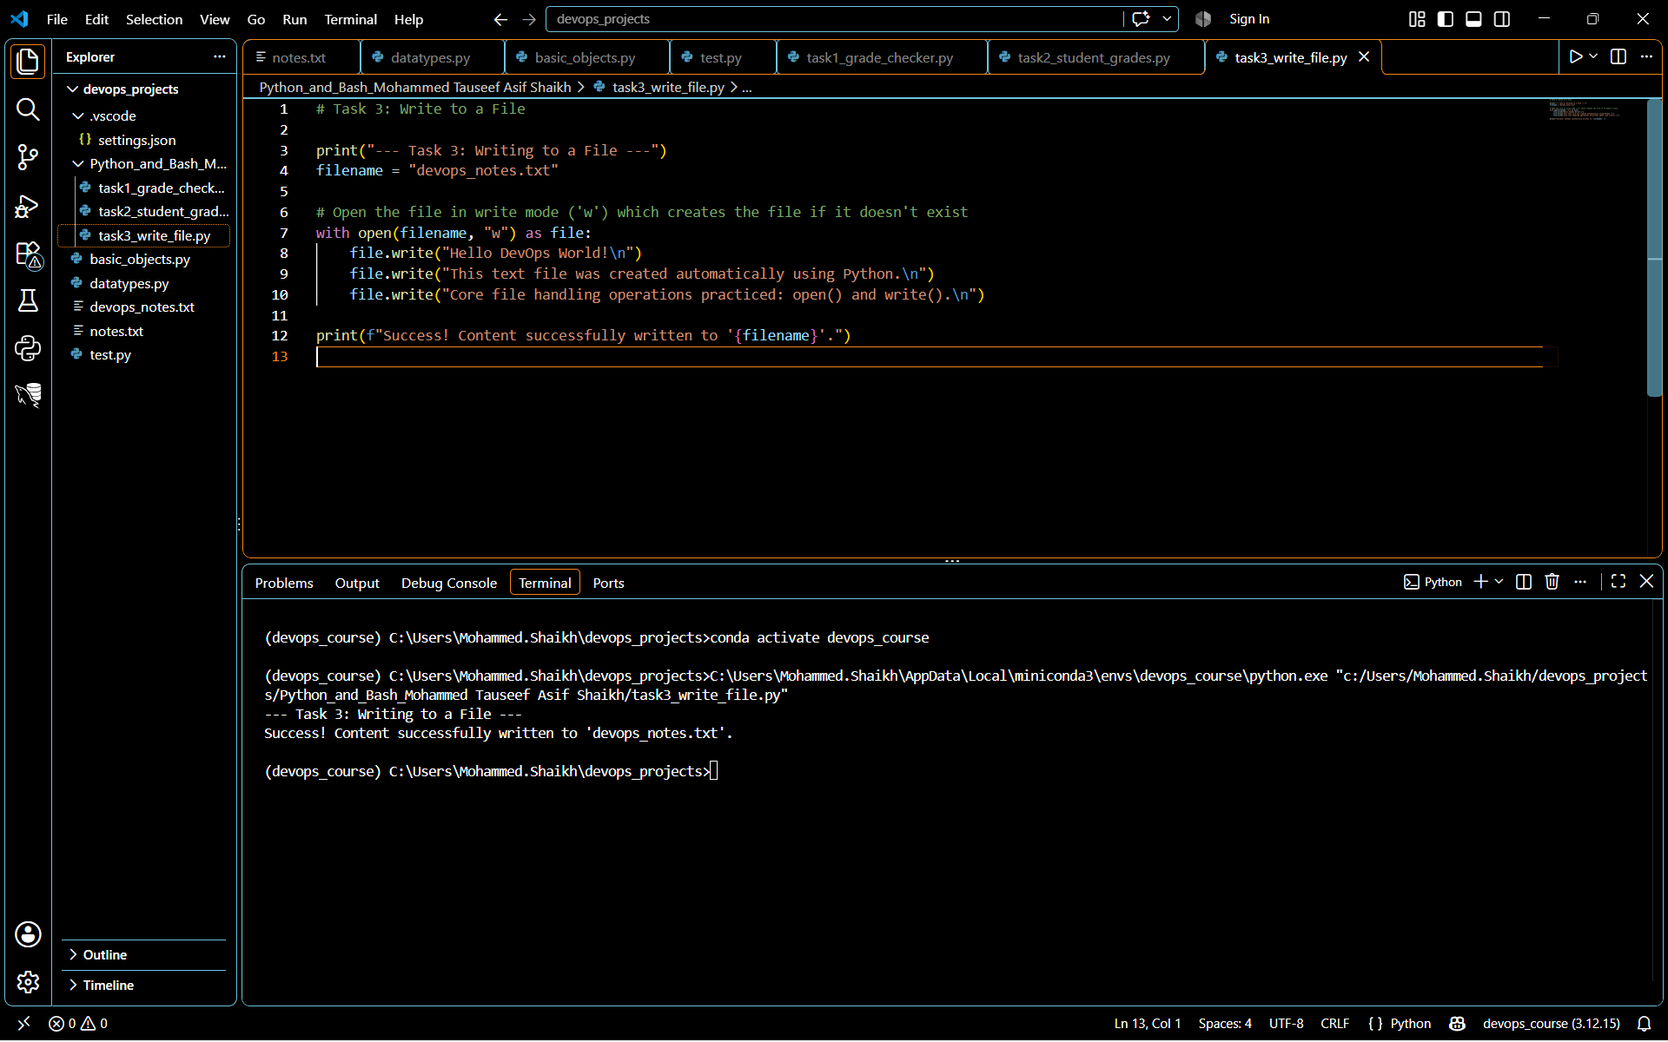

4. Read from a File
- Open the file in read mode and use file.read() to read and display its content.
Source Code:
# Task 4: Read from a File

print("--- Task 4: Reading from a File ---")
filename = "devops_notes.txt"

# Open the file in read mode ('r')
with open(filename, "r") as file:
content = file.read()

# Display the content in the terminal
print("File Content Displayed Below:")
print("---------------------------------")
print(content)
print("---------------------------------")

SS:
